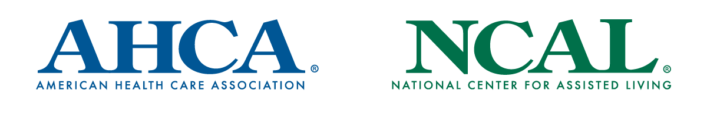

Template Newsletter Article

COVID-19 Vaccine Updates
We are thrilled to share with you that the U.S. Food and Drug Administration approved Pfizer's request for emergency use authorization (EUA) of its COVID-19 vaccine. This is incredible news and something worth celebrating in what has been a challenging year.

As previously shared, the Centers for Disease Control and Prevention recently recommended that long term care residents and staff be included at the highest priority level for the first distributions of this vaccine.

[If vaccine clinic is scheduled]:
We will begin giving the vaccine to residents and staff [Insert details on vaccine clinic – date, time, location]. In order for the pharmacy to administer the vaccine, we need consent. Completed consent forms (scanned) and/or general consent should be emailed to [insert email]. There will be no costs to get the vaccine, and you can review the EUA fact sheet here.

[If a facility won’t have the vaccine for a while but starts to collect consent forms:]
The COVID-19 vaccine will soon be available to all residents and staff. We are moving forward with our plans and will provide additional details soon. In the meantime, we need your consent for the pharmacy to administer the vaccine. Completed consent forms (scanned) and/or general consent should be emailed to [insert email]. There will be no costs to get the vaccine, and you can review the EUA fact sheet here.

We encourage as many residents and staff as possible to get this vaccine. The elderly have a much higher risk for getting very sick, being hospitalized, or dying from COVID-19. The vaccine has been shown to provide a great deal of protection against serious illness due to COVID-19. The more residents and staff that get vaccinated, the better we can protect our community against potential outbreaks and save lives.

This vaccine has gone through testing and clinical trials to ensure it meets the highest safety standards. It also is safe to get if you already had the virus. The health and safety of our residents is always our top priority, and we are confident this vaccine is a much better option than the risk of getting this virus.

And you can rest assured that we will continue to take all necessary precautions after the vaccine is administered, including wearing personal protective equipment and conducting regular testing, to ensure the safety of our residents and staff. We will also work with public health officials to determine how and when to adjust our policies for visitations and social activities and keep you updated.

There is a light at the end of the tunnel. We are hopeful that the vaccine will be a lifesaving turning point in the fight against COVID-19. Please do not hesitate to reach out to us with any questions. You may also visit www.cdc.gov/coronavirus/2019-ncov/vaccines to learn more about the vaccine.

###

